Year 5
Novel Study Curriculum




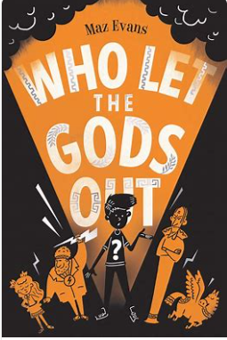


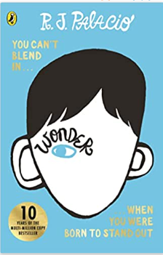

Autumn 1 Text Types Coverage:
Balanced Argument
Diary Entries
1st Person Narrative (Falling overboard, landing on deserted island, meeting island inhabitants)
Kenzuke Biography
Poem
Notes:
- Arguments for and against sailing the world in the Peggy Sue
- Study Michael’s log entries. Write own. Can you write log entries from the perspective of Michael’s parents after Michael goes missing? Focus on emotions, feelings and thoughts.
- Study scene where Michael goes overboard. Watch videos of wild sea. Write scene with a focus on powerful verbs and adverbs.
- You land on island… what happens next?
*Literacy shed planning available
*Hamilton planning available

Autumn 2 Text Types Coverage:
Third Person Narrative
Instructions – How to care for a Minotaur
Job application

Notes
- Setting description about the cave where Thanatos is found
- Character description of escaped prisoner 42
- Timeline of thoughts and feelings of prisoner 42
- Dialogue – between Prisoner 42, Elliot and Virgo - use of speech
- Third person narrative

*Literacy Shed planning

Spring 1 Text Types Coverage:
First day of school descriptions
Character description of August (exploring different POVs)
Devising and performing a short role-play theme of bullying
Diary Entry
Letter to Mr Tushman
Narrative – First person account of Halloween
Speech

Notes:
* Thoughts and feelings on attending first day at school
Diary entry on events in the woods
- Letter expressing likes and dislikes about the visit to school/end of school year
- After reading chapter about Halloween, write first person account.
- Describe August from different characters perspectives
- Write a speech for August to say at Daisy’s funeral.
- *Literacy shed planning available

Spring 2 Text Type Coverage
Setting Description
Letter Writing
Non-Chronological Reports
Dialogue to enhance characterisation
A political address

Notes
- Setting description of Mister Tom’s house
- Third person narrative – evacuee meeting host for the first time
- Dialogue to enhance characterisation between Willie and Mister Tom
- Use formal language to write political address

Summer 1 Text Types Coverage:
Character profile
Suspense narrative
Biography
Setting description
Explanation text
Eye witness report

Notes
- Character profile of Daniel or Lucien Silver
- Suspense narrative – use ellipses, short sentences and rhetorical questions, expanded noun phrases to describe character and setting. Study Ross Mackenzie’s style and emulate him.
- Biography of Lucien Silver’s life.

- *Literacy shed planning available

Summer 2 Text Type Coverage

Narrative – house move.
Setting description
Character description (building tension)
Prediction Writing (create predictions on Michael’s predicament, in the form of a free write in the style of the author)
Instructions
Persuasive writing – house advertisement

Notes
- Building Tension – study scene where Michael finds Skellig (Highlight examples of techniques: the use of short sentences (Just me.); maintaining anonymity of the threat (something moved, I thought he was dead); negative adjectives (rotten, fallen, rusty, ancient); asking questions (What could it be?); and slow movements (tiptoeing, slowly, carefully).
- Character Description – describing an odd creature that speaks in a human voice
- Create predictions on Michael’s predicament, in the style of the author
- House advertisement on house on Falconer Street
- How to care for a mythical creature instructions – Michael cares for Skellig, use this as stimulus.
- Thoughts and feelings from different characters (Mum, Dad and Michael) of first impressions of moving into the new house
- Describe setting of abandoned abbey and finding a creature
- Describe Skellig

Autumn SPag Coverage:
Revision:
- Basic punctuation
- Word classes
- Co-ordinating conjunctions/subordinating conjunctions
- Determiners
- Dialogue/punctuating dialogue/speech rules
- Expanded noun phrases
- Pronouns
- First person, second person, third person
- Tenses
- Paragraphs
- Apostrophes (for omission and possession)
Year 5:
- Suffixes: converting nouns or adjectives into verbs using “-ate”, “-ise” or “-ify”
- Verb prefixes: “dis-”, “de-”, “mis-”, “over-” and “re-”
- Indicating degrees of possibility using modal verbs: might, should, will, must
- Indicating degrees of possibility using adverbs: perhaps, surely
- Embellishing simple sentences
- Formal and informal language
- Persuasive devices: Repetition to persuade; exaggerated language: unbelievable, glorious, etc.
- Pattern of three for persuasion: Fun. Exciting. Adventerous!
- Rhetorical questions (persuasive techniques)
- Brackets, Dashes and Commas for parenthesis.
- Relative pronouns: who, which, that, whom, whose
- Relative clauses to add detail beginning with “who”, “which”, “where”, “when”, “whose”, “that”, or an omitted relative pronoun
- **Editing sentences by either expanding or reducing for meaning and effect**
- Secure use of compound sentences*

Alan Peat Autumn Sentences Yr 5
Sentence Type | Example | Rule | Link to N.C
Noun,  which/who/where | Cakes, which taste fantastic, are not so good for your health.  Snakes, which scare me, are not always  poisonous.  Tom, who was a little shorter than the others, still made it into the football team. | Use commas to embed a clause within a sentence, add information that links with  the sentence topic and start the clause with which, who or where. | Relative clauses beginning with who, which,  where, when, whose, that, or an omitted  relative pronoun p.78 (English Appendix 2)
Name – adjective  pair – sentences | Little Tim – happy and generous – was always fun to be around.  Ben Roberts – weak and nervy – was actually a secret superhero.  Glass – fragile and dangerous – must be handled with care. | This works on a show and tell basis where  the name and details form the main clause  (tell). The added information within the  dashes shows what the character was like.  The two must be linked. | Brackets, dashes or commas to indicate  parenthesis p.78 (English Appendix 2)

Spring Spag coverage:
Year 5:
- Revise key SPaG
- A sentence that gives three actions: Tom slammed the door, threw his books on the floor and slumped to the ground.
- Formal and informal language
- Modal verbs of possibility and obligation
- Persuasive devices
- Tenses and perspective
- Developing technical language
- Connectives to build cohesions: Exemplification, Results, To summarise, To sequence.
- **Editing sentences by either expanding or reducing for meaning and effect**
- Linking ideas across paragraphs using adverbials of time (later), place (nearby) and sequence (secondly)
- Indefinite pronouns: somebody, something, someone, nobody, nothing, no-one, everything, anything, nothing
- Moving parts of sentences around to create different effects**
- Colons to start a list
- Onomatopoeia
- Future tense verbs
- Rhetorical questions

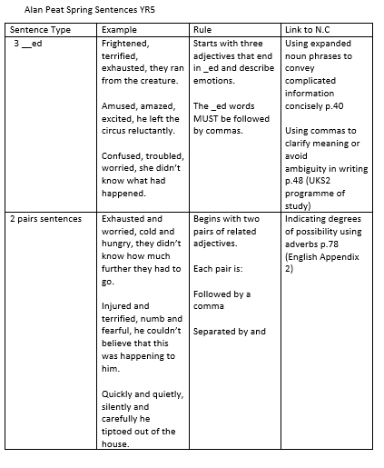

Summer Spag coverage:

Year 5:
- Revise key SPaG taught in Autumn + Spring Term
- The importance of powerful verbs, adverbs, adjectives
- Varied sentence types
- Varied sentence lengths (to build tension/atmosphere)
- Prepositions and prepositional phrases
- Speech to reveal character/to move story forward
- Embellishing simple sentences
- Start a complex sentence with a subordinate clause and use a comma to separate the subordinate clause
- Personification (setting descriptions)
- Metaphors
- Drop-in “-ed” clauses: Poor Tom, frightened by the fierce dragon, ran home.
- **Developing fronted prepositional phrases for greater effect: Throughout the stormy winter… Far beneath the frozen soil… **
- Start a sentence with an expanded “-ed” clause: Frightened of the dark, Tom hid under the bed all night.
- **Editing sentences by either expanding or reducing for meaning and effect**
- Secure use of compound sentences**

Alan Peat Summer Sentences yr 5
Sentence Type | Example | Rule | Link to N.C
3 bad – (dash)  question? | Cold, dark, airlessness – which would kill the  spaceman first?  Greed, jealousy, hatred – which of these is most  evil? | 3 negatives followed by a dash and then a  question which relates to the three  adjectives. | Brackets, dashes or commas to indicate  parenthesis p.78 (English Appendix 2)
O. (I.) | She told the little girl not to be so naughty.  (Inside, however, she was secretly amused by  what she had done.)  I was delighted (but I felt scared that something  was about to go wrong).  Bravely I looked behind me (but I was deeply  worried). | The first sentence tells the reader a  character’s outward action and the second  reveals their true feelings.  If the sentence within the brackets is complete, the full stop goes inside the  bracket. If it is not complete, the full stop goes outside. | Brackets, dashes or commas to indicate  parenthesis p.78 (English Appendix 2)

